Slide # | On-Screen text (Minimal) | Visuals & Animation | Audio/ Narration | Developer Notes & Interaction
2.0.0 | (Main Title) Module 2: The Guest and The Journey | Visual: Cinematic video of a XYZ ship sailing through Glacier Bay.  Animation: Title text "shimmers" in gold. | (Music: Upbeat, nautical theme) | (Auto-play)  (Button) [START MODULE 2] button appears after narration.
2.0.1 | Welcome Back! | (Visual)  Character: Sam face avatar appears in the ship’s atrium or with a world map on his background. | Sam: "Welcome back! In Module 1, we learned who we are as a brand. Now, we look at the 'Who, Where, and When' of the guest experience. This module defines the lifecycle of a voyage and the unique personalities of the people we serve." | Interaction: Click "Next" to see our mission.
2.0.2 | Mission Map:  Stop 1: The Voyage  Stop 2: The Guest  Stop 3: The Website  Stop 4: Accessible Cruising | (Visual) A premium "Mission Map."(same with PBOS module) | Sam: "Here is our roadmap. We’ll first explore the 'rhythm' of the voyage, so you can prepare for high-pressure days and manage your tasks effectively. Then, we’ll meet our guest personas, which helps you tailor your communication to every type of traveler. Next, we’ll dive into the XYZ website—your external source of truth for answering those tricky guest questions with total confidence. Finally, we’ll dive into how XYZ provide safe and accessible voyage for all guests." | Interaction: User MUST click "Stop 1" to begin. Stops 2, 3, and 4 are grayed out/locked until previous sections are complete.  Interaction: Auto-transitions to Slide 2.1.0.
2.1.0 | Where We Sail | Visual: A World Map with scattered ship icons highlighting XYZ's 12 regions with pop animations:  1. Alaska  2. Asia  3. Australia/NZ  4. Canada/NE  5. Caribbean  6. Mediterranean  7. Mexico  8. Northern Europe  9. Pacific Coast  10. Panama Canal  11. South America/Antarctica  12. South Pacific | Sam: "XYZ is a global brand. While the desk procedures are the same, the guest needs change by region. Alaska guests ask about glaciers; Caribbean guests ask about beach towels. Hover over the regions to see where we sail." | Interaction: Slide will complete once all locations are revealed. Users can click on the icons to read again the location on the map to give exploration feels.
2.1.1 | Our Famous Destinations | Visual: 6 interactive tiles that will play videos when clicked.  Visual: Image + Text  Costa Rica  Dominica  Bonaire  Aruba  Bahamas  Alaska | Sam: “Now, Let’s look at some famous destinations our guests enjoy when cruising with us. Click each button to know more.” | Developer Note: Download videos from XYZ YT Channel  Puntarenas, Costa Rica  (https://www.youtube.com/watch?v=9rUHqttaZyU)  Roseau, Dominica  (https://www.youtube.com/watch?v=hx19njebC1Q)  Kralendjik, Bonaire  (https://www.youtube.com/watch?v=VqeyWM0kaXc)  Oranjestad, Aruba  (https://www.youtube.com/watch?v=IRgOroPJwVU)  Relax Away, XYZf-Moon Cay, Bahamas (https://www.youtube.com/watch?v=UgnaTMWTW-I)  Alaska ( https://www.youtube.com/watch?v=-OPaHnoMJDQ)
2.1.2 | The 7- Day Voyage  Setting the Pace | Visual: Infographic showing a calendar page highlighting Sunday-Saturday.  Animation: Text fades in: 1 Day to 4 Months.  Layer: A "7-Day Cruise Itinerary " play button appears. | Sam: "XYZ sails the world, with cruises ranging from a day to over 4 months. To keep things simple, we use a 7-day cruise itinerary as our example. It’s the perfect snapshot to learn the operational rhythm you'll experience at the desk. Click the button to see what a typical week in the Caribbean looks like." | Interaction:  1. Auto-plays Sam's intro.  2. User clicks "7-Day Cruise Itinerary"  3. This triggers the 7-Day Eastern Caribbean Itinerary Video Overlay.  Mini-Storyboard: 7-Day Eastern Caribbean Video  Scene 1: Intro  Visual:  The Eurodam ship in Fort Lauderdale. A simple map shows the ship moving from Florida to the islands.  Voiceover:  "Welcome to a 7-day cruise. Our trip starts in Fort Lauderdale, Florida. This city is famous for its many canals and boats. Guests board the ship here to start their vacation."  Scene 2: Day 1  Visual:  Guests on the ship deck, smiling and looking at the ocean as the ship leaves the port.  Voiceover:  "At 4:00 PM, the ship leaves the port. The adventure begins as we sail toward the Caribbean Sea."  Scene 3: Day 2  Visual:  White sand beaches. Guests riding horses in the water. A private villa with a butler serving lunch.  Voiceover:  "Day 2 is at XYZf Moon Cay. This is our private island. Guests love the white sand and clear blue water. They can ride horses in the ocean or relax in a private beach house with a butler."  Scene 4: Day 3  Visual:  Visual: A guest getting a massage at the spa. People sitting by the pool.  Voiceover:  "Day 3 is a 'Sea Day.' The ship is moving, but we do not stop at a port. Guests use this time to rest. They go to the spa, swim in the pool, or just relax on the deck."  Scene 5: Day 4  Visual:  A guest looking through a glass-bottom boat at colorful fish. A Jeep driving on a dirt road past a wild donkey.  Voiceover:  "On Day 4, we arrive in Grand Turk. This island has very deep blue water. Guests can go snorkeling to see colorful fish. They can also drive Jeeps to see the old lighthouse and wild donkeys."  Scene 6: Day 5  Visual:  A street with colorful umbrellas hanging above. A person rolling a cigar. A guest eating a piece of chocolate.  Voiceover:  "Day 5 is Amber Cove in the Dominican Republic. This day is about history and food. Guests walk through colorful streets, see how cigars are made, and taste local Dominican chocolate."  Scene 7: Day 6  Visual:  The sun setting over the ocean. Guests eating a nice dinner in the dining room.  Voiceover:  "Day 6 is our second Sea Day. It is a quiet time for guests to enjoy a nice dinner and think about their favorite parts of the trip."  Scene 8: Day 7  Visual:  Old stone stairs (Queen's Staircase). A colorful market with local crafts.  Voiceover:  "Day 7 is Nassau, Bahamas. Guests visit the famous stone stairs and old forts. They also enjoy the local food and shopping before the trip ends."  Scene 9: Conclusion  Visual:  The ship arrives back in Florida. Sam (the guide) appears and smiles.  Voiceover:  "On Day 8, we return to Fort Lauderdale. The guests leave with many memories. As a GSA, when you know what the guests did each day, you can provide much better service. Now let's look at what each phase means for you at the desk."
2.1.3 | The Operational Rhythm | Visual: A circular diagram labeled "Voyage Lifecycle” with 3 checkpoints.  Animation: Clickable Ship icon moves through the 3 phases after showing the definition in a text box for each phase.  Operational Phases:  1. Embarkation (Day 1):  High volume, account setups, key card issues.  On-Screen Text + Audio: Check-in is the first impression.  2. Onboard and Port (Days 2-6):  Dining changes, shore excursion help, general info.  On-Screen Text + Audio : Onboard stay is about exploration  3. Disembarkation (Day 7):  Bill disputes, lost & found, transportation.  On-Screen Text + Audio : Disembarkation is the final memory. | Sam: "Using our 7-day itinerary, you'll see that every voyage has a lifecycle that resets every week. Each day has a different priority for us at the desk. Let's look at the three main phases."  "Timing is everything. Regardless of the cruise length, Embarkation and the night before we go home are our busiest hours." | Interaction: Slide will complete once all ship icons were clicked and viewed and completes one full loop.
2.1.4 | The Guest’s Point of View | Visual: Sequence Game: 2 split panels  On-Screent Text:  "The journey starts long before they see the ship. Can you put the guest's travel steps in the correct order? Click the boxes to build the timeline."  Left Panel:  Visuals:  TRAVEL STEPS:  Onboard – Living on the Eurodam  The Pier – Checking in at the port  Back Home – Returning after the cruise  Home – Packing bags and getting ready  Airport – Flying to the ship’s city  Sample Layout:  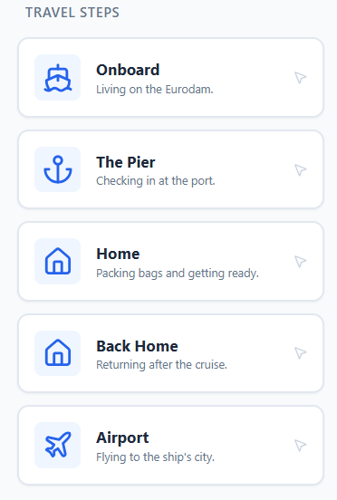  Right Panel:  Visuals:  THE TIMELINE  1st Slot: Drop the correct stage here  2nd – 6th Slots locked: Complete previous steps first  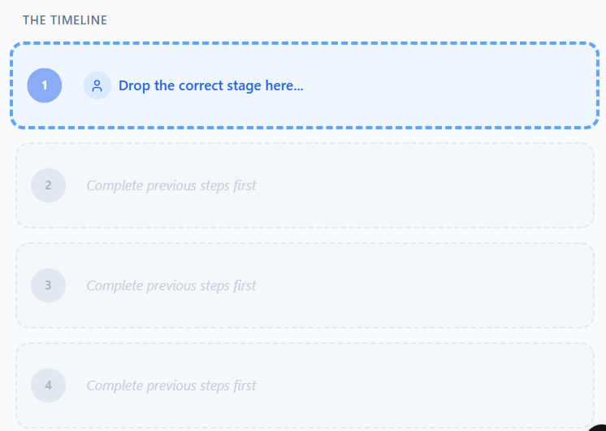 | Sam: "As a GSA, remember that every guest you meet is at a different point on this timeline. Can you put the guest’s travel steps in the correct order?"  Sam: Great Job!  You correctly mapped the guest's feelings and needs. The guest’s journey starts long before they see the ship. From the moment they leave home, they are in 'Savor the Journey' mode. | Interaction: User drags the item on the left and drops on the correct slot on the right. Feedback will appear once answer is correct, if incorrect, it will snap back to its original position.  Developer Note: Slots will unlock only when the correct image was dragged to the current active slot.  Correct sequence:  Home -> Airport -> The Pier -> Onboard -> Back Home  Feedback:  Home  Visual:  Green Check mark; Home icon  On- Screen Text:  Guest Perspective  "I feel: I am excited but a little bit nervous about my trip."  Need: I need clear information and an easy way to start my travel.  Airport  Visual:  Green Check mark; Airplane icon  On- Screen Text:  Guest Perspective  "I feel: I am tired from traveling and the airport is very busy."  Need: I want to arrive safely and get to the port without stress.  The Pier  Visual:  Green Check mark; Ship Anchor icon  On- Screen Text:  Guest Perspective  "I feel: I can see the big ship! I am very happy to be here."  Need: I want to check in quickly and feel welcome by the staff.  Onboard  Visual:  Green Check mark; Ship icon  On- Screen Text:  Guest Perspective  "I feel: This is the best part! I am finally on my vacation."  Need: I want to explore the ship, eat good food, and have fun.  Back Home  Visual:  Green Check mark; Home icon  On- Screen Text:  "I feel: I am sad the trip is over, but I have many happy memories."  Need: I want a smooth trip home so I can tell my friends about my cruise.  Sample Layout:  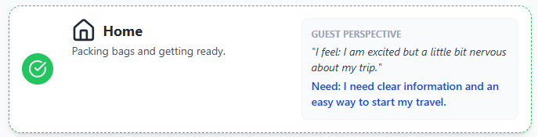
2.0.2b | Mission Map:  Stop 1: 1 The Voyage  Stop 2: The Guest  Stop 3: The Website  Stop 4: Accessible Cruising | (Visual) A premium "Mission Map."(same with PBOS module) | Sam: "Now, let’s talk about the 'Who.' A 'milestone' is a big, important event in life, like a 50th wedding anniversary or retirement. Most of our guests are 'Milestone Explorers.' This means they are traveling with us to celebrate these special moments.  They usually come from  North America, the UK, and the Netherlands. They value tradition, elegance, and deep destination knowledge." | Interaction: User MUST click "Stop 2" to begin. Stop 1 has a checkmark and Stop 3 is grayed out/locked until previous sections are complete.  Interaction: Auto-transitions to Slide 2.2.0
2.2.0 | Our Guests | Visual: Flip Cards showing images of people that represent top 8 nationalities.  Front: Blank  Back: image + nationality text  Main Nationalities:  USA  Germany  The United Kingdom  People’s Republic of China  Australia  Canada  Spain  The Netherlands | Sam: "Our guests come from across the globe, flip all cards to see the top nationalities we normally have as our guests on our ships.”  Sam: “XYZ has a strong Dutch heritage; expect many guests from the Netherlands on European and Transatlantic sailings.” | Interaction: Slide will be completed once all cards have been flipped.
2.2.1 | Guest Culture and Personas | Visual:  Two Main Tabs: Images of different nationalities on a flip card  Header when Tab 1 is active (default):  Cultural Intelligence  Don't just read about them—learn to DECODE them. Flip the cards to see a real-world scenario for each nationality. How would you react?  Tab 1: Culture  Front: Image+Nationality text; Decode Behavior button to flip  Back: Cultural + Service Tip  American  The Scenario: “I’ve only got 5 minutes before my tour leaves. Can we fix this bill quickly?”  Why they act this way:  Value efficiency and directness. Time is their most precious currency.  Your Strategy:  Be fast, maintain direct eye contact, and skip the fluff.  German  The Scenario  “The schedule says the bus departs at 09:00. It is now 09:02. Why are we still here?”  Why they act this way  Strict punctuality and logic. They value order over casual small talk.  Your Strategy  Use formal titles (Mr./Ms.), provide exact facts, and be 100% punctual.  British  The Scenario  “I’m terribly sorry to bother you, but I think there might be a small hiccup with my cabin.”  Why they act this way  Reserved and avoid direct confrontation. 'Small hiccup' might mean a big problem.  Your Strategy  Read between the lines. Listen for subtle cues and mirror their politeness.  Chinese  The Scenario  A guest approaches with their elderly parents and waits for you to acknowledge the father first.  Why they act this way  High respect for hierarchy and 'Saving Face.' Direct 'No' is considered rude.  Your Strategy  Acknowledge the eldest first. If you must say no, offer a 'difficult but  Australian  The Scenario  “G'day! Don't worry about the wait, mate. Just happy to be here!”  Why they act this way  Egalitarian 'Mateship.' They treat staff as equals and dislike over-formality.  Your Strategy  Be relaxed and friendly. Use humor where appropriate but stay professional.  Canadian  The Scenario  “I’m so sorry, but could I possibly get an extra towel? Only if it's not too much trouble!”  Why they act this way  Famous for politeness and community-mindedness. They dislike being a 'burden'.  Your Strategy  Reassure them that helping is your pleasure. Match their high level of courtesy.  Spanish  The Scenario  A guest stands close to you, uses many hand gestures, and speaks with high energy about their dinner.  Why they act this way  Expressive and social. Physical proximity is a sign of engagement, not intrusion.  Your Strategy  Be warm and animated. Don't back away—it can be seen as cold or unfriendly.  Dutch  The Scenario  “This coffee is cold. Please get me a hot one now.”  Why they act this way  Pragmatic and honest. Directness is not rudeness; it's efficiency.  Your Strategy  Don't take it personally. Be direct back, fix the issue, and avoid over-explaining.  Sample Layout Front:  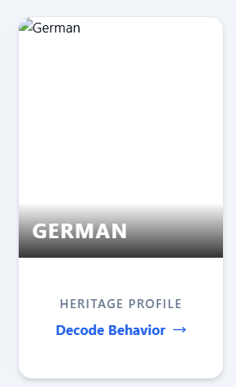  Sample Layout Back:  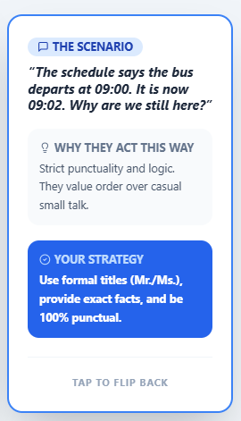  Header when Tab 2 is active:  Cultural Intelligence  Who is standing in front of you? Identify the persona to anticipate their needs before they even ask.”  Tab 2: Guest Personas  Visual: Three "Profile Cards":  Front Image+ Text  The Loyal Mariner  70+ years old, 500+ days at sea.  Content (Back of Cards):  Top Priority  Values recognition and 'The XYZ Way.'  GSA Strategy  They expect you to know their history. They love consistency and being called by name.  Front Image+ Text  The Milestone Couple  50-60 years old. Celebrating a 30th anniversary.  Content (Back of Cards):  Top Priority  Needs 'Special Moments.'  GSA Strategy  This is a bucket-list trip. Small gestures like a handwritten note make their entire cruise.  Front Image+ Text  The Multi-Gen Family  Large group (Grandparents to toddlers).  Content (Back of Cards):  Top Priority  Needs logistical help.  GSA Strategy  Solving 'group pain points' (like dining tables for 12) is their biggest need.  Sample Layout Front:  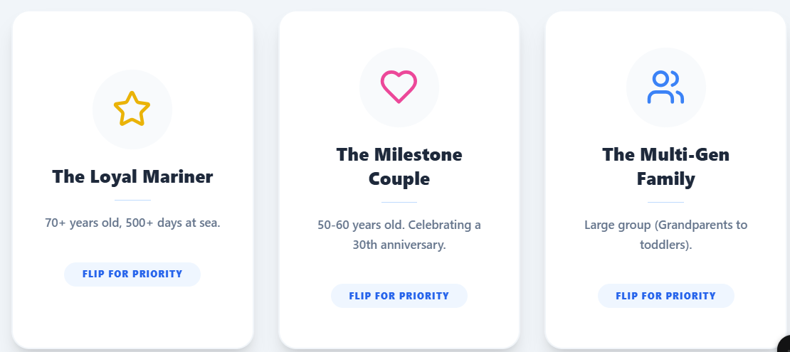  Sample Layout Back:  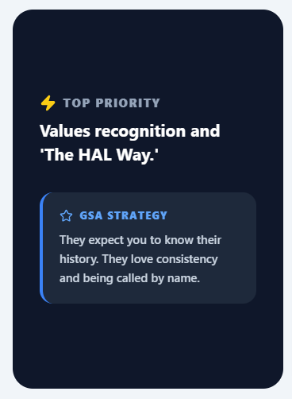 | Sam Tab 1: “Our core 'Mariners' are often from North America and the Netherlands. Understanding their cultural background helps you tailor your communication at the desk. These are general patterns — every guest is an individual."  Sam Tab 2: "We serve three main types of guests. Meet the 'Loyal Mariner,' the 'Milestone Couple,' and the 'Multi-Gen Family.' Each group has different priorities. Flip their cards to see what they need most from the Guest Service Desk." | Interaction Tab 1: Flip the cards to see "Cultural and Service Tip."  Interaction Tab 2: 3 Flip the cards to see “Guest Personas Profile”.
2.2.2 | The Guest’s Persona Matching Game | Visual: 2 split panels  On-Screen Text:  Header:Listening Lab: Profile Decoder  "Listen for the tone, look for the clues."  Left Panel:  GUEST QUEUE  Mr. Van Der Meer  The Miller Family  Mrs. Sterling  The Garcia Couple  Mr. Li  Sample Layout Left:  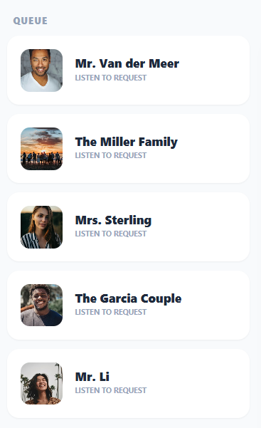  Right Panel:  Select a guest from the queue to start profiling.  Sample Layout Right:  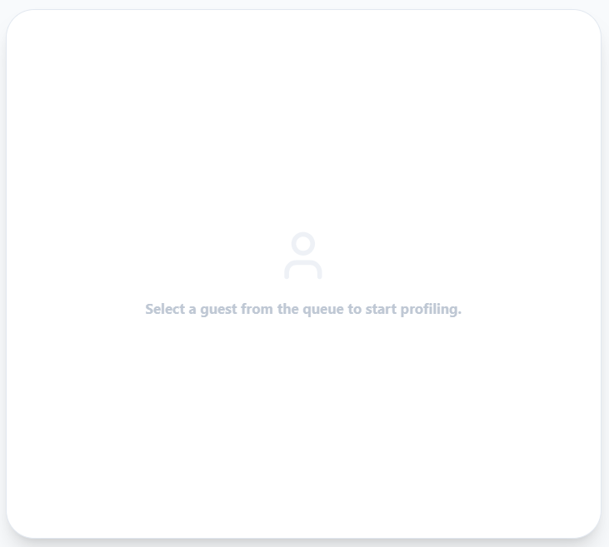  Right Panel Activated when an item on the left is clicked:  Mr. Van der Meer  Tag: Audio available, Transcript available  Visual: Speaker icon (clickable)  Text: Click to listen  On-screen text:  Observation Hint  Notice the Mariner Society pin on his lapel and his focus on established service standards.  On-screen text:  Transcript  “I’ve been on this ship many times and the soup is usually excellent, but this bowl was served cold. Please get me a warm one now. No need for an apology, just the warm soup.”  On-screen text: 1. Culture  Buttons:  American  Dutch (correct answer)  British  Spanish  Chinese  On-screen text: 2. Persona  Buttons:  Loyal Mariner (correct answer)  Milestone Couple  Multi-Gen Family  The Miller Family  Tag: Audio available, Transcript available  Visual: Speaker icon (clickable)  Text: Click to listen  On-screen text:  Observation Hint  Multiple family members of different ages are present, all looking at their watches.  On-screen text:  Transcript  "We've only got 5 minutes before our tour leaves! Can we quickly fix this bill? 24 hours in a day is just not enough!"  On-screen text: 1. Culture  Buttons:  American (correct answer)  Dutch  British  Spanish  Chinese  On-screen text: 2. Persona  Buttons:  Loyal Mariner  Milestone Couple  Multi-Gen Family (correct answer)  Mrs. Sterling  Tag: Audio available, Transcript available  Visual: Speaker icon (clickable)  Text: Click to listen  On-screen text:  Observation Hint  Notice the 4-Star Mariner Society medallion on her lanyard and how casually she references past sailings and ship names.  On-screen text:  Transcript  "I'm terribly sorry to bother you, but I think there might be a small hiccup with my stateroom's air conditioning. It was exactly like this on the Rotterdam last season."  On-screen text: 1. Culture  Buttons:  American  Dutch  British (correct answer)  Spanish  Chinese  On-screen text: 2. Persona  Buttons:  Loyal Mariner (correct answer)  Milestone Couple  Multi-Gen Family  The Garcia Couple  Tag: Audio available, Transcript available  Visual: Speaker icon (clickable)  Text: Click to listen  On-screen text:  Observation Hint  They are holding hands, standing close, and sweet to each other.  On-screen text:  Transcript  "Hola! We are so excited for our anniversary dinner tonight! It must be perfect, no? We have been waiting all year for this!"  On-screen text: 1. Culture  Buttons:  American  Dutch  British  Spanish (correct answer)  Chinese  On-screen text: 2. Persona  Buttons:  Loyal Mariner  Milestone Couple (correct answer)  Multi-Gen Family  Mr. Li  Tag: Audio available, Transcript available  Visual: Speaker icon (clickable)  Text: Click to listen  On-screen text:  Stands slightly behind the elders of the group, showing deferential body language to his parents.  On-screen text:  Transcript  "I am traveling with my family. We require the arrangements for the senior members to be handled first, if you please."  On-screen text: 1. Culture  Buttons:  American  Dutch  British  Spanish  Chinese (correct answer)  On-screen text: 2. Persona  Buttons:  Loyal Mariner  Milestone Couple  Multi-Gen Family (correct answer)  Sample Layout:  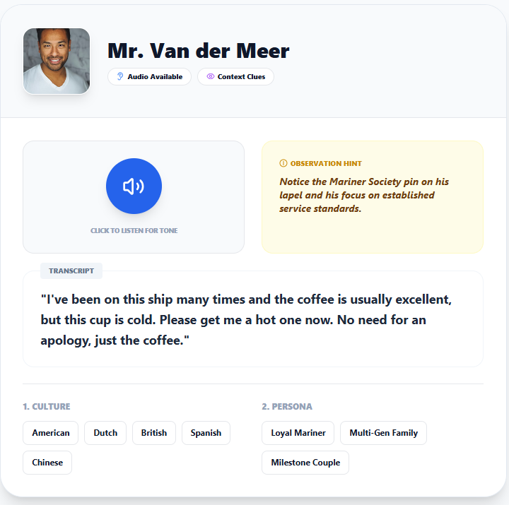 |  | Interaction: User clicks on the guests’ queue from the left panel and the scenario will show up on the right panel. Once the learner selects the guest culture and person at the bottom, the feedback layer will appear. User can click on Next Guest Button on the feedback layer to proceed.  Feedback Layer:  Correct Feedback Mr. Van Der Meer:  Visual:  Green Check mark  On-Screen Text:  Accurate Profile!  Deep Dive  "Dutch guests value pragmatic honesty and directness. They rely on words over body language."  The XYZ Approach (Do's)  Be direct, efficient, and avoid over-apologizing for minor issues.  What to Avoid (Don'ts)  Don't refer to the entire country as 'Holland' (use The Netherlands). Don't take their blunt communication style as rudeness or anger.  Sample Layout Correct:  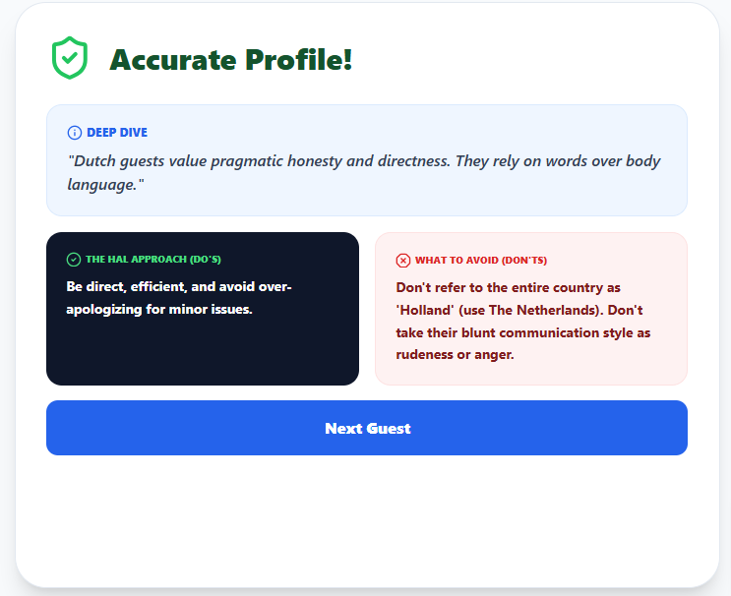  Correct Feedback The Miller Family:  Visual:  Green Check mark  On-Screen Text:  Accurate Profile!  Deep Dive  "Americans are highly individualistic and often feel rushed. They love small talk about sports or weather to build rapport."  The XYZ Approach (Do's)  Keep energy high. Use 'small talk' to connect while working quickly to solve their issue.  What to Avoid (Don'ts)  Don't be slow or vague in your answers. Avoid sensitive topics like politics or religion during small talk.  Correct Feedback Mrs. Sterling:  Visual:  Green Check mark  On-Screen Text:  Accurate Profile!  Deep Dive  "The British use 'understatements.' A 'small hiccup' often means a major problem. They value privacy and personal space highly."  The XYZ Approach (Do's)  Mirror their politeness, use formal titles (Mr./Mrs.), and take their 'minor' complaints very seriously.  What to Avoid (Don'ts)  Don't invade their personal space. Avoid excessive hand gestures, as they prefer a more reserved interaction.  Correct Feedback The Garcia Couple:  Visual:  Green Check mark  On-Screen Text:  Accurate Profile!  Deep Dive  "Spanish culture is social and warm. They value physical proximity and use many hand gestures to emphasize points."  The XYZ Approach (Do's)  Be warm and animated. Celebrate their milestone with enthusiasm and a big smile.  What to Avoid (Don'ts)  Don't back away if they stand closer to you than usual—this can be perceived as cold or unfriendly.  Correct Feedback Mr. Li:  Visual:  Green Check mark  On-Screen Text:  Accurate Profile!  Deep Dive  "Respect for hierarchy is paramount. 'Saving Face' is critical in the Chinese culture."  The XYZ Approach (Do's)  Acknowledge the eldest first. Maintain formal titles and always use an open palm to point directions.  What to Avoid (Don'ts)  NEVER point with your index finger or curl your finger to beckon them. Never correct them publicly, which causes them to 'lose face'.  Incorrect Feedback Layer:  On-Screen Text:  Communication Misstep  Look closer. Check the 'Observation Hint' and transcript again.  Button: Try Again  Sample Layout Incorrect:  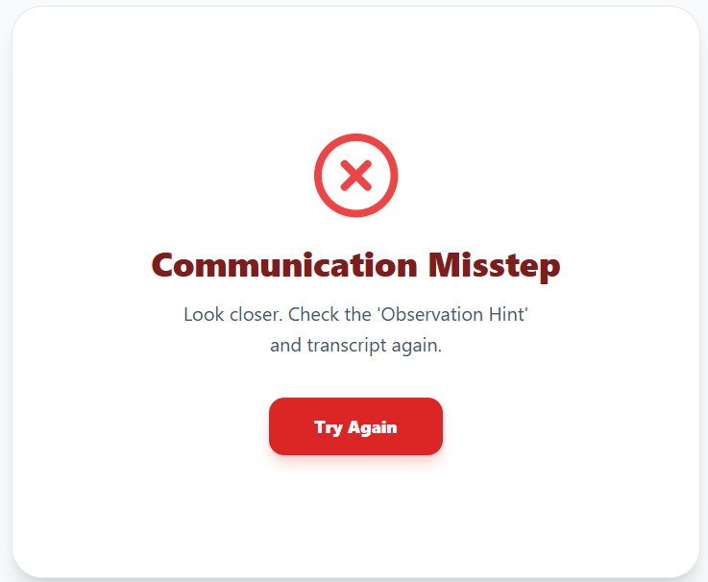
2.0.2c | Mission Map | Visual: Mission Map. Stop 1 and 2 has a checkmark. Stop 3 (The Website) is now open. Stop 4 is still locked. | Sam: "One last stop! Let's look at the tool you'll share with the guests: The XYZ Website." | Interaction: User clicks Stop 3.
2.3.0 | The XYZ Website | Visual: Image of the XYZ homepage on a laptop.  On-Screen Text: The Public Source of Truth. | Sam: "The website is your first line of defense. If a guest asks about a future cruise or a general policy, the answer is usually right here. On the next slides, we’ll show you how to use and navigate the website as a customer and as a Guest Service Associate." | Auto plays
2.3.1 | Navigating the XYZ Website Part 1 | Visual:  On-Screen Text:  Navigating Your Next Adventure (Customer Perspective)  Estimated Length: 3:00- 5:00 minutes  Tone: Vibrant, inspiring, welcoming, and easy to follow.  [SCENE START]  [Audio] Upbeat, inspiring acoustic guitar music begins.  [Visual - B-Roll] A beautiful sweeping drone shot of a XYZ ship gliding through a glacier in Alaska.  [Visual - Screen Capture] Transition to a clean, full-screen recording of the XYZ homepage (xyz.com).  [Narrator (Warm, enthusiastic)] "Welcome to the digital gateway of XYZ! Long before you step aboard our beautiful ships, your journey begins right here on our website. Today, we’re going to step into the shoes of our guests and walk through how easy it is to dream, plan, and book your next great adventure."  [UI Action] Cursor moves fluidly to the top global navigation bar.  [Visual] A subtle highlight effect illuminates the top navigation menu.  [Narrator] "Our website is designed to follow a guest's natural planning journey. It all starts with choosing a region."  [UI Action] Cursor hovers over, then clicks the "Destinations" tab in the main navigation bar.  [Visual] The Destinations mega-menu drops down, revealing columns of global regions. Cursor smoothly scrolls through the options to show variety.  [Narrator] "First is the Destinations tab. Here, guests can see all the incredible places our ships sail to globally. From the Caribbean to Europe, it’s the perfect starting point to explore different regions and itineraries."  [UI Action] Cursor moves across the top navigation bar to the right and clicks on the "Alaska" tab.  [Visual] The screen transitions to the dedicated Alaska landing page, featuring a large hero video of a glacier and wildlife.  [Narrator] "Because XYZ is the recognized leader in the Great Land, guests will find a dedicated Alaska tab right next to Destinations. Clicking here highlights all of our exclusive Alaska itineraries, Cruisetours, and breathtaking experiences specific to this popular region."  [UI Action] Cursor moves back to the main navigation bar and clicks on the "Ship Life" tab.  [Visual] The page transitions. The cursor scrolls down to show a grid of images featuring dining plates, swimming pools, and a cabin interior. The cursor then hovers over a 'Deck Plans' link.  [Narrator] "Once the destination is chosen, guests want to know about their home at sea. The Ship Life tab is where they can visualize their experience. Here, they can see the different restaurants, explore our world-class amenities, view photos of the staterooms, and even look at ship deck plans to get a clear idea of where they will be boarding and staying."  [UI Action] Cursor moves up to the main navigation and clicks on the "Deals" tab.  [Visual] The Deals page loads, showing vibrant promotional banners (e.g., "Have It All", special onboard credit offers, or discounted fares).  [Narrator] "Everyone loves a great deal. By clicking the Deals tab, guests can instantly see any special fares and offers XYZ is providing, ensuring they can take full advantage of the best value for their vacation."  [UI Action] Cursor clicks the XYZ logo in the top left to return to the homepage. Cursor moves to the prominent search banner in the center of the screen.  [Visual] Highlight the main search widget area. A subtle graphic overlay reads: Improved Layout.  [Narrator] "When guests are ready to narrow down their search, our new web features make booking easier than ever. The improved layout brings departure dates, prices, and deals together all at a glance."  [UI Action] Cursor clicks the "Destinations" dropdown and selects 'Caribbean'. Cursor clicks the "Dates" dropdown and selects a month. Cursor clicks the "Duration" dropdown and selects '7-8 Days'. Finally, cursor clicks the prominent "Search" button.  [Visual] The screen transitions to a loading animation, then reveals the search results page showing a list of matching itineraries.  [Narrator] "By utilizing our new search filters right on the homepage, guests can simply plug in their destination, travel dates, and duration to instantly find cruises that perfectly match their dream itinerary and their budget."  [UI Action] Cursor moves to the top right of the search results and toggles the "Compare by Price" switch.  [Visual] The screen layout dynamically transforms into a side-by-side pricing grid, clearly displaying columns for Inside, Ocean View, Verandah, and Suite prices across multiple sailings.  [Narrator] "And here is a true a significantly improved feature: the new Price Toggle. With one click, guests can compare stateroom prices side by side. They can see exactly what's right for them—from inside cabins to luxurious suites—giving them more clarity and confidence in every click."  [UI Action] [DEVELOPER NOTE - CRITICAL PATHWAY:] Cursor must now navigate back to the main global navigation bar at the top of the screen. Cursor clicks the "Book Cruises" tab. A dropdown menu appears. Cursor clicks on a specific "Duration" option (e.g., 7-10 Days).  [Visual] The website explicitly routes the user to a new Search Results page populated with various different itineraries matching that selected duration.  [Narrator] "Alternatively, guests can perform a deep dive starting right from the main navigation. By clicking the Book Cruises tab and selecting a travel duration, they are instantly routed to a page showcasing all the different itineraries that match their timeframe."  [UI Action] [DEVELOPER NOTE - CRITICAL PATHWAY CONTINUED:] Cursor scrolls down this list of different itineraries. Cursor hovers over one specific cruise card and explicitly clicks the "View Cruise" button.  [Visual] The screen transitions directly to the highly detailed Cruise Itinerary Page for that specific sailing.  [Narrator] "Once they browse the options and find a voyage that catches their eye, clicking the View Cruise button opens up a wealth of information."  [UI Action] Cursor slowly scrolls down the page, pausing briefly at each specific section as the narrator mentions it.  [Visual] Subtle highlight boxes pop up around each section as the cursor reaches it.  [Narrator] "This detailed page acts as their ultimate digital brochure. Here, guests can review “The Daily” for itinerary day-by-day, trace their route on the interactive itinerary map, and explore included activities and things to do in each port. As they scroll further, they'll find a clear breakdown of the price, interactive ship deck plans, and all available staterooms options to help them choose their perfect cabin."  [UI Action] Cursor scrolls back to the very top right corner of the website header. Cursor hovers over the "Manage My Cruise" tab.  [Visual] A dropdown menu appears.  [Narrator] "But the website's utility doesn't end at booking. For guests who already have a reservation, the Manage My Cruise tab is essential. This is where they go to make updates, add shore excursions, or make any changes to their upcoming booking."  [UI Action] Cursor stays in the top right corner and clicks the "Log In / Register" link right next to the Manage tab.  [Visual] The screen transitions to a clean login and account creation portal. The cursor clicks in the 'Email' field.  [Narrator] "And for ultimate convenience, customers can easily register, create an account, and log in to the website to keep all their cruise history, preferences, and future bookings in one secure place."  [Visual - B-Roll] Montage of happy guests looking at a tablet together on a couch, then cutting to them raising a glass on a ship deck. Text on screen: Your Journey Starts Here.  [Narrator] "From finding that perfect itinerary with our new search tools, to managing the final details, the new XYZ website puts the world right at their fingertips. More clarity, more choice, more confidence."  [Audio] Music swells and fades out with the XYZ logo on screen.  [SCENE END] | Sam (VO): | Developer Logic:  Video must have "Pause/Play" and "Replay" buttons.  Reference Materials:  XYZ Official Website  XYZ Youtube Channel:  https://www.youtube.com/watch?v=Ekm-SdTNmxk
2.3.2 | Navigating the XYZ Website Part 2 | Visual:  On-Screen Text: The GSA Toolkit: Navigating the XYZ Website (Associate Perspective)  Part 2: The GSA Toolkit: Navigating the XYZ Website as a GSA  Estimated Length: 3.5 - 4.5 Minutes  Tone: Professional, empowering, instructional, and highly accurate.  [SCENE START]  [Audio] A modern, upbeat electronic track with a steady, driving rhythm (signifying efficiency and focus).  [Visual - B-Roll] A GSA in a crisp uniform standing confidently behind the Front Office desk, smiling.  [Visual - Screen Capture] The screen splits: the GSA on the left, a live capture of the XYZ website homepage on the right.  [Narrator (Professional, encouraging, confident)] "As a Guest Service Associate, you are the ultimate problem-solver. But you don't have to memorize every single policy! The XYZ website is not just a marketing tool for guests—it is your most powerful, up-to-date resource. Let’s explore how navigating to the bottom of the screen can instantly boost your confidence and elevate your service."  [UI Action] On the screen recording, the user scrolls rapidly all the way down to the bottom of the homepage to reveal the global footer area.  [Visual] A highlight box draws attention to the columns of links in the dark footer.  [Narrator] "When a guest asks a complex question, the website is your single source of truth. Most of what you need is located right here in the website footer. Today, we are highlighting three critical sections every GSA must know to provide accurate information."  [UI Action] Cursor navigates to the column specifically labeled "Plan & Manage Your Cruise". Cursor clicks on the text link "Know Before You Go".  [Visual] The page loads the 'Know Before You Go' landing page. Cursor slowly scrolls through the sections. A bold lower-third graphic appears: 1. Know Before You Go. Text bullets appear on screen: Travel Documents, Passport & Visas, Packing & Dress Code, Boarding Procedures.  [Narrator] "First, look under the 'Plan & Manage Your Cruise' column for the Know Before You Go link. This page is your ultimate guide for logistical and pre-cruise queries. Here you can easily locate our official stance on required Travel Documents, find out exactly what visas or passports are needed for specific itineraries, check packing guidelines including dress codes for Dressy Nights, and review our step-by-step boarding procedures."  [UI Action] Cursor scrolls back down to the footer. Under the column specifically labeled "Customer Support", cursor clicks on the text link "Cruise FAQs".  [Visual] The 'Frequently Asked Questions' page loads, showing a prominent search bar and categorized drop-down menus. Cursor clicks a drop-down labeled 'Onboard Policies'. A bold lower-third graphic appears: 2. Cruise FAQs. Text bullets appear on screen: Crew Appreciation, Internet Packages, Beverage Limits, Onboard Policies.  [Narrator] "Next, under the 'Customer Support' column, you'll find the Cruise FAQs—your go-to resource for common questions at the desk. This section provides immediate, bite-sized answers on a wide variety of topics. You can find precise details on how the Crew Appreciation charge works, learn about our various internet and beverage packages, and review general onboard policies. It's the perfect tool for providing fast, documented answers."  [UI Action] Cursor scrolls to the absolute bottom of the page, below the main footer columns, to the tiny text in the fine print copyright area. Cursor clicks on the text link labeled "Cruise Contract".  [Visual] A formal legal document page loads. The text is dense. A bold lower-third graphic appears: 3. Cruise Contract. Text bullets appear on screen: Age Requirements, Alcohol & Smoking Fines, Environmental Fines, Baggage Liability, Pregnancy Limits.  [Narrator] "Finally, at the very bottom of the page in the fine print, is the Cruise Contract. While we hope you don't need it often, it is vital for complex or escalated situations. This document contains the legal backbone of our policies."  [Visual - Screen Capture] Call-out boxes temporarily magnify sections of the contract as the narrator speaks.  [Narrator] "For example, Section 5 outlines strict age requirements—from infant sailing minimums to the 21-year-old drinking age—as well as our exact alcohol carry-on allowances and corkage fees. It also details the $250 cleaning fee for smoking in staterooms, the $500 fine for environmental discharge violations, baggage liability limits, and the policy restricting guests entering their 24th week of pregnancy. If a guest cXYZlenges a strict rule, showing them the Cruise Contract removes personal conflict from the interaction. It shifts the conversation to our official, legal agreements."  [Visual - B-Roll] The split screen returns: the GSA calmly showing a guest a tablet displaying the website. The guest nods happily.  [Narrator] "Remember, saying 'Let me check our official resources' is a sign of a great GSA. Master the Know Before You Go, the Cruise FAQs, and the Cruise Contract. Let the website be your guide, so you can be the expert our guests rely on."  [Audio] Music hits a high, confident note and fades out with the XYZ Hotel Academy logo.  [SCENE END]
2.3.3 | Explore Your Resource | Visual: A split composition. On the left, a confident GSA at the front desk. On the right, a glowing laptop screen displaying the XYZ homepage.  Animation: A large, stylized web link banner pops up on screen: www.xyz.com with a subtle glowing effect. | Sam: "Now you've seen the website from both sides of the desk! From inspiring our guests' dreams to providing you with the exact policies you need, the XYZ website is your ultimate tool. I highly encourage you to open a browser and explore the site on your own. Click through the deck plans, read the FAQs, and find the Cruise FAQs and locate the Crew Appreciation policy, or simply get familiar with your new most reliable resource. When you're ready, click 'Next' to test your knowledge in our Module Check-In!" | Visual: Clicking "Next" routes the learner to Slide 2.4.0 (Module Check-In).
2.0.2c | Mission Map | Visual: Mission Map. Stops 1,2, and 3 has a checkmark. Stop 4 (Accessible Cruising) is now open. | Sam: "We have one final stop before our module check-in. XYZ is committed to providing safe and accessible accommodations for all guests." | Interaction: User clicks Stop 4.
2.4.0 | Independent Care & Mobility:  - Capable Traveling Companion  - Mobility Assist Team (MAT)  - SNAS / Care Vacations | Visual:  Left: Icon of two guests walking together.  Center: Icon of a crew member assisting a guest at a gangway.  Right: Icon of a mobility scooter. | Sam: "While we do everything we can to assist, our crew cannot dedicate time to help guests with basic needs like eating or dressing. Guests who need this care must travel with a capable companion.  At the gangways, our Mobility Assist Team, or MAT, is always ready to help guests get on and off the ship. For equipment rentals, guests use approved partners like Special Needs at Sea or Care Vacations." | Auto-play.  (Button) [NEXT]
2.4.1 | The Assistance Timeline:  1. Embarkation: Shore Ops  2. Mid-Cruise: MAT (No sign-up)  3. Disembarkation: Guest Services | Visual: A 3-step timeline graphic.  1. Embarkation: Icon of a cruise terminal.  2. Mid-Cruise: Icon of a gangway.  3. Disembarkation: Icon of the Front Desk with a "Sign-up List" clipboard. | Sam: "As a GSA, you need to know exactly when a guest will rely on your desk for wheelchair assistance.  At embarkation, Shore Operations handles boarding. During mid-cruise ports, our Mobility Assist Team, or MAT, is stationed at the gangways to help—no sign-up needed.  However, for disembarkation, guests must contact Guest Services. You will log their request so our Admin team can send them a letter with a specific meeting time and lounge location for their departure." | Animation: Highlight Step 3 (Disembarkation) with a gold pulse effect as Sam mentions it, emphasizing that this is a direct GSA responsibility.  (Button) [NEXT]
2.4.2 | Tender Port Safety:  The 100 lbs Rule | Visual: Split screen.  Left: Icon of a heavy mobility scooter with a large red "X" over it, with text "Over 100 lbs (without battery)".  Right: A tender boat on the water. | Sam: "Tender ports require extra safety checks. Scooters and wheelchairs that weigh more than 100 pounds without the battery are not allowed on tender boats.  Additionally, the Captain makes the final decision on whether it is safe for guests with limited mobility to go ashore, depending on the weather and ocean waves. Guest Services is responsible for communicating these restrictions sensitively." | Developer Note: Emphasize the "100 lbs" text visually. This is a critical safety and operational rule GSAs must memorize.  (Button) [NEXT]
2.4.3 | Accommodations:  - Service Animals  - Sensory Kits | Visual:  Left: Icon of a service dog wearing a vest. Text: "Trained tasks only. No Emotional Support Animals."  Right: Icon of a flashing light/bed shaker alarm (Sensory Kit). | Sam: "We welcome trained service animals that perform specific tasks. Please note, emotional support animals are not allowed.  For guests with visual or hearing impairments, we provide stateroom kits. These include visual and tactile alerts for door knocking, phone ringing, and safety alarms." | Auto-play.  (Button) [NEXT]
2.4.4 | Practice: At the Desk | Visual: A guest in a large, heavy motorized scooter approaches the desk.  Speech Bubble; On-screen Text with Audio: "Good morning! We are at a tender port today. I am ready to go ashore, but my scooter is quite large and heavy. Can the crew just lift it onto the tender boat for me?"  On-Screen Text:  How should you answer this guest?  A) "Yes, of course! Our Mobility Assist Team (MAT) will carry your scooter onto the tender boat right away.”  B) "For your safety, equipment over 100 pounds without the battery cannot go on tender boats. Let me check the exact weight of your model with you first."  C) "No, you must stay on the ship today. Guests with disabilities are never allowed to use tender boats." | (No audio – check-in mode) | Interaction (Multiple Choice Scenario):  Correct Answer: B.  Unlimited retries.  Feedback Layer (Appears based on selection):  If A: (Red 'X') "Incorrect. The Mobility Assist Team (MAT) only assists at the gangway, and crew cannot lift overweight scooters."  If B: (Green Checkmark) "Excellent! You confidently applied the 100 lbs. safety rule."  If C: (Red 'X') "Incorrect. Guests with disabilities can tender if their equipment is under the weight limit and weather permits."
2.5.0 | Module Check-In  Question 1 | Visuals: Image representation of the scenario below  On Screen Text:  Scenario: It is Day 6 of a 7-day Alaskan cruise. A guest approaches the Front Desk looking slightly anxious and holding a folded piece of paper. Based on the "7-Day Guest Rhythm," what is the most likely reason for their visit?  A) They are holding “The Daily” and are frustrated about a scheduling conflict between the mainstage show and their dining time.  B) They have questions about the disembarkation process, luggage tags, and their airport transfer.  C) They are looking for recommendations on where to eat dinner tonight. | Sam: “Before we officially wrap up Module 2, let's see how much of the Guest and the Journey you've retained. Answer the following three scenarios based on what we've learned.” | Interaction: Feedback Layer will show up once an answer is submitted.  Correct Answer: B  Correct Feedback Layer:  (Green checkmark) "Spot on! By Day 6, guests transition from 'vacation mode' to 'travel mode.' Anticipating their anxiety about packing and getting home helps you provide reassuring, proactive service."  Incorrect Feedback Layer:  (Red 'X') "Not quite. While guests do ask about schedules or dining, the '7-Day Rhythm' tells us that by Day 6, their primary focus shifts to the stress of packing and disembarkation. Always anticipate travel-related anxiety toward the end of the voyage."
2.5.1 | Module Check-In  Question 2 | Visuals: Image representation of the scenario below  On Screen Text:  Scenario: Mr. van der Berg, a Dutch guest, approaches the desk with a question about the beverage package charges on his folio. Based on the Dutch cultural persona, what is your best approach to handling his inquiry?  A) Be highly energetic, make lots of small talk, and use enthusiastic language to make him smile.  B) Be direct, efficient, and provide a clear, factual breakdown of the charges without excessive small talk.  C) Apologize profusely for the confusion and immediately offer him a complimentary bottle of wine to avoid conflict. |  | Interaction: Feedback Layer will show up once an answer is submitted.  Correct Answer: B  Correct Feedback Layer:  (Green checkmark) "Correct! The Dutch cultural persona highly values transparency, efficiency, and direct communication. Giving a clear, factual answer is the best way to earn their trust and provide excellent service."  Incorrect Feedback Layer:  (Red 'X') "That's not the best approach here. The Dutch cultural persona values directness, efficiency, and clear facts over excessive small talk or over-apologizing. Providing a straightforward, factual breakdown is the best way to assist him."
2.5.2 | Module Check-In  Question 3 | Visuals: Image representation of the scenario below  On Screen Text:  Scenario: A guest has a specific question regarding the legal terms of their booking and asks to see the official policy. As a GSA, you know the fastest way to find this is on the live XYZ website. Where should you look to find the official "Cruise Contract"? | A) Click the "Destinations" tab at the top of the homepage and select "Legal."  B) Go to the "Manage My Cruise" section and search for their specific booking number.  C) Scroll all the way down to the bottom footer of the homepage and click the "Cruise Contract" link. | Interaction: Feedback Layer will show up once an answer is submitted.  Correct Answer: C  Correct Feedback Layer:  (Green checkmark) "Exactly! The website footer is your secret weapon. It houses all the crucial policy documents, including the Cruise Contract, making it easy to find exactly what you or the guest needs in seconds."  Incorrect Feedback Layer:  (Red 'X') "Incorrect. The fastest and most reliable place to find official policy documents, including the Cruise Contract, is by scrolling to the very bottom footer of the XYZ homepage. It's a GSA's quick-reference guide!"
2.5.3 | Module Wrap-up | Visual: Wrap-up Slide template  Module Complete! | (Sam): "Fantastic job! You now understand the rhythm of our guests' voyage, how to adapt to their unique cultures, and how to use our website as a powerful tool. You are well on your way to becoming a Front Desk superstar. Click 'Next Module' when you're ready to continue!" | Interaction: User clicks [EXIT MODULE 2] to return to the main LMS dashboard or trigger completion.

